Antenna Arrays

**Introduction**

For some applications single element antennas are unable to meet the gain or radiation pattern requirements. Combining several single antenna elements in an array can be a possible solution.

**Antenna arrays, radiation pattern and array factor**

The antenna elements can be arranged to form a 1 or 2 dimensional **antenna array**. Antennas exhibit a specific radiation pattern. The overall radiation pattern changes when

several antenna elements are combined in an array. This is due to the so called **array factor**: this factor quantifies the effect of combining radiating elements in an array without the element specific radiation pattern taken into account. The overall radiation pattern of an array is determined by this array factor combined with the radiation pattern of the antenna element. The overall radiation pattern results in a certain directivity and thus gain linked through the **efficiency** with the directivity. Directivity and gain are equal if the efficiency is 100%.

**Broadside vs. end fire arrays**

Arrays can be designed to radiate in either **broadside** i.e. radiation perpendicular to array orientation (the z­axis in figure 1) or **end fire** i.e. radiation in the same direction as the array orientation (the y­axis in figure 1). Focus is on broadside arrays and only radiation in the z direction is considered. This allows for easy transformation to 2­ dimensional planar arrays with the elements in the x­y plane. For linear arrays the radiation patterns given below are a cross section in the y­z plane. Actually, the 3­ dimensional radiation pattern of a linear array is a rotation around the y­axis of the patterns given.

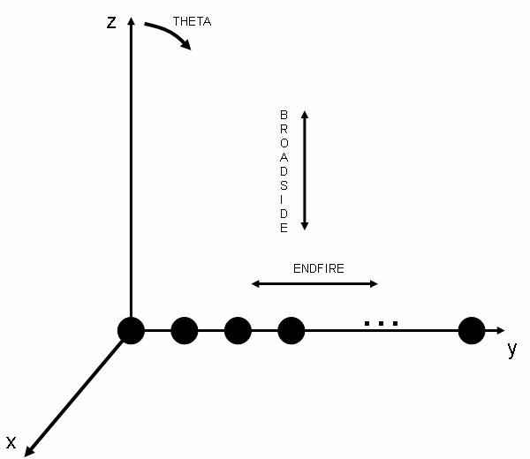

**Topology of a linear array.**

**Array factor**

The array factor depends on the number of elements, the element spacing, amplitude and phase of the applied signal to each element. The number of elements and the element spacing determine the surface area of the overall radiating structure. This surface area is called **aperture**. A larger aperture results in a higher gain. The **aperture efficiency** quantifies how efficiently the aperture is used. The influence of these parameters will be explained with the aid of a linear array of **isotropic** radiating elements. An isotropic radiating element radiates an equal amount of power in all directions, i.e. it has a directivity of 1 (0dB) and a gain of 1 (0dB) if the efficiency were 100%. In the outline bellow the array factor is normalized to the array directivity. This results in more intuitive and realistic radiation pattern plots.

**Influence of the number of elements on the array factor**

The array directivity increases with the number of elements. Figure 2 shows the directivity of 3 arrays with 2 (red), 5 (green) and 10 (blue) elements. The element spacing is 0.4 times the wavelength (λ) for all the arrays in figure 2. Note the presence of **side lobes** next to the main lobes: this is typical for arrays. The number of side lobes and the side lobe level increase with the number of elements. It is important to note that due to the array factor definition there are 2 main lobes. There is a main lobe at theta 0° (positive z axis) and a main lobe at theta 180°/­180° (negative z axis).

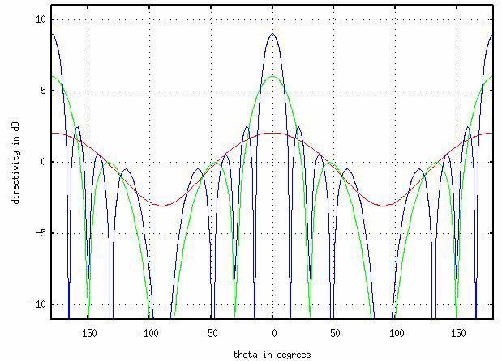

**Figure 2: Directivity of a 2 (red), 5 (green) and 10 (blue) element array with 0.4 λ**

**element spacing.**

**Influence of the element spacing on the array factor**

The element spacing has a large influence on the array factor as well. A larger element spacing results is a higher directivity. However, the element spacing is generally kept smaller than λ/2 to avoid the occurrence of **grating lobes**. A grating lobe is another unwanted peak value in the radiation pattern of the array. Figures 3, 4 and 5 show the array factors of a 5­element array with various element spacing.

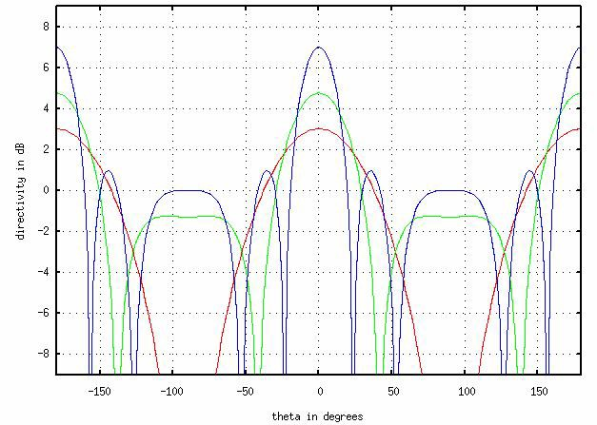

**Figure 3: Directivity of a 5 elements array with 0.2 (red), 0.3 (green) and 0.5 (blue)**

**times λ** **element spacing.**

Increasing the element spacing towards λ results in an increased directivity and grating lobe effect with a maximum grating lobe amplitude equal to the main lobe magnitude at an element spacing λ as shown in figure 4.

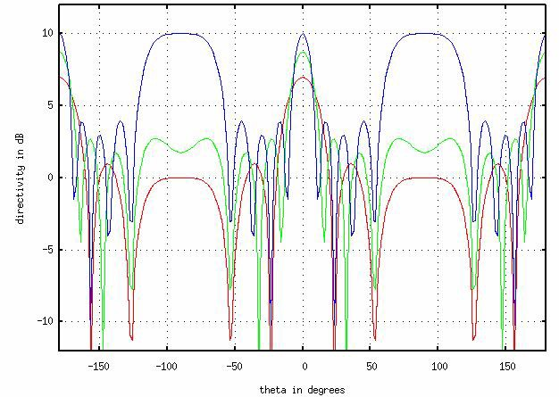

**Figure 4: Directivity of a 5 elements array with 0.5 (red), 0.75 (green) and 1 (blue)**

**times λ** **element spacing.**

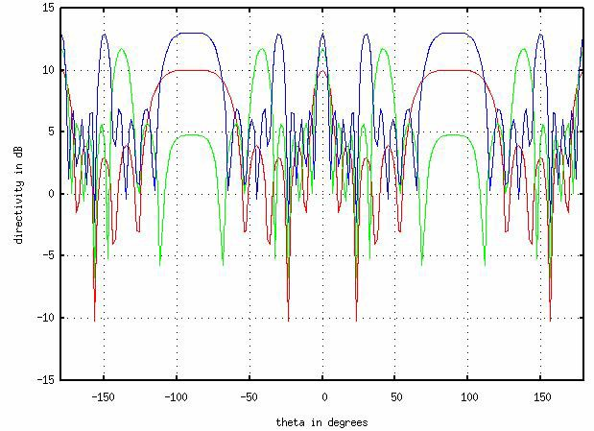An element spacing beyond λ becomes impractical and results in multiple unwanted grating lobes as depicted in figure 5.

**Figure 5: Directivity of a 5 elements array with 1 (red), 1.5 (green) and 2 (blue)**

**times λ** **element spacing.**

**Influence of the radiating element properties on the overall radiation pattern**

A number of examples of total radiation patterns are given below in order to give an idea

of the effect of the radiating element radiation pattern on the overall array radiation pattern. Figure 6 shows the radiation pattern of an isotropic element (red), the array factor and the combined radiation pattern (both green). In this case the overall radiation pattern is the same as the array factor since an isotropic element radiates the same amount of

power in all directions.

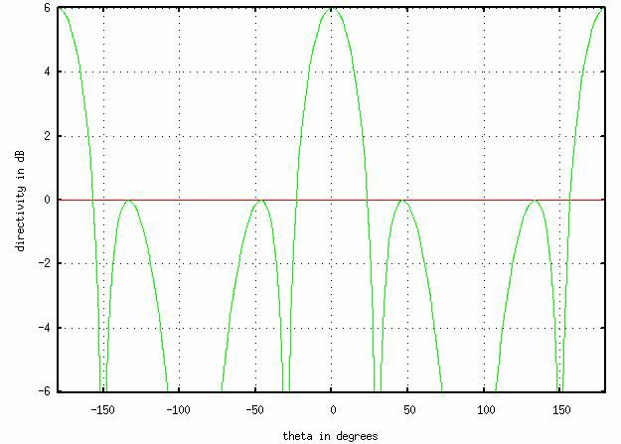

**Figure 6: Directivity of an isotropic source (red) in a 5 elements array (green) with**

**0.4 λ** **element spacing.**

**Feeding of an array**

In the previously discussed arrays the element spacing has been kept constant and the elements were fed with the same amplitude and phase. The resulting arrays **were linear arrays with uniform spacing, uniform amplitude and equal phase**. However, the power does not necessarily have to be distributed with equal amplitude and/or phase. Unequal power and phase distribution to the individual elements can be used to modify the side lobe level, directivity and direction of the main lobe. A range of standard amplitude and phase distributions exists (e.g. uniform, cosine pedestal) but this is beyond the scope of this article. The reader should realize that any modification to an array will have some adverse effect on the performance of the array and a careful trade off is required. When the power distribution is optimized to reduce the side lobe level, the efficiency of the array decreases; when the phase distribution is optimized to do **beam steering**, new side lobes will show up as the main beam is deflected sideways.

**Feed network of the array**

The individual antenna elements in an array are fed using a feed network. The complexity of the feed network depends on the number of elements, the amplitude and/or phase distribution between the elements, the ability to do beam steering… It is important to realize that the feed network is the most complex part of the array.